**DATABASE MANAGEMENT ON FLIGHT PUNCTUALITY**

TABLE OF CONTENTS

Introduction 3

Discussion 3

Conclusion 12

Reference list 14

# Introduction

Being on time is crucial in today's fast-paced society, especially in the aeroplane business. In addition to enhancing customer satisfaction, on-time arrivals, as well as departures, also guarantee operational efficiency and safety. The United Kingdom's airlines are a crucial component in transporting people worldwide and domestic areas as an important point of transportation. Monitoring the UK airports' regularity data offers substantial insights into both how they function and the country's broader air travel scenario. The objective of this prologue is to give an in-depth analysis of the timeliness metrics in UK airports, stressing how significant they are and exposing the variables determining how well they perform. One can delve into the current state of promptness, analyse trends, and explore steps produced to enhance airport services and passenger experience by reviewing multiple sources of information as well as industry documents. In the beginning, it's crucial for understanding what punctuality implies in the framework of travel by air. On-time achievement, which evaluates when a flight arrived or landed within an amount of time defined by the transport company or the regulatory body, is an accepted method to measure tardiness. Although humble delays are commonplace and frequently inescapable as a result of things like adverse conditions or air traffic gridlock, airports aim to keep distractions to a minimum while preserving high levels of dependability.

# Discussion

Database management is essential for tracking and enhancing the on-time performance of flights. Airlines can see trends, foresee delays, and put policies into place to increase overall punctuality by efficiently maintaining and analysing data connected to flights. Let's talk about the several facets of database administration in connection to on-time departures. Airlines acquire a lot of knowledge on flight operations, which includes gate assignments, the crew plans, reports of weather, and records of aircraft repairs (Xiang, Y. *et al,* 2021). This data has been gathered from an assortment of sources, such as third-party suppliers, airport infrastructure, and flight management software. In a database system, the gathered data must be effectively and securely kept. Information about flights is frequently organised and stored using relational database management systems (RDBMS) or cloud-based storage options. The selection of a database system is influenced by elements including data security, performance, and scalability. Airlines frequently need to combine information from many sources to get a complete picture of flight punctuality. Utilising integration enables them to identify possible delays by correlating variables including weather, airspace congestion, and crew availability. Data warehousing or the use of data integration technologies can be used to achieve this integration.

A constant stream of data is produced by flight operations, and this data must be analysed quickly. This involves keeping track of gate assignments, weather reports, and flight status. Airlines can quickly identify schedule violations and take preventative action to reduce delays because of real-time data processing. Data analysis is made easier by database management systems, which include capabilities for reporting, querying, and visualisation. Airlines can utilise historical data analysis to spot trends, patterns, and usual reasons for delays (Yang, Z. *et al,* 2021). The creation of prediction models and the optimisation of flight plans to increase punctuality can both benefit from this approach. Airlines may use predictive analytics algorithms to foresee future delays by using historical and real-time data. Using data trends and variables like weather, past performance, and airport congestion, machine learning algorithms can forecast the possibility of delays. This enables airlines to effectively and proactively alter timetables, distribute resources, and notify passengers. Integration is essential between aviation systems and database management systems. For instance, connecting crew management systems with the flight operations database can assist in optimising crew scheduling and reduce delays brought on by problems with staff availability. Sensitive information including passenger and crew profiles and operational data are all included in in-flight data. To prevent unauthorised access to or data breaches, database management systems must follow stringent security measures (Miao, X., 2022). To ensure data security, encryption, access control, and frequent security audits are crucial. This report will discuss whether enhancing flying on-time performance requires excellent database administration. Airlines may acquire useful insights, streamline operations, and improve the overall timeliness of their flights by gathering, storing, integrating, analysing, and safeguarding flight-related data.

**1. OLTP System**

A data warehouse may help businesses in several ways, especially with decision-making, analytics, and reporting. The following are some major benefits of employing a data warehouse. Data warehouses combine information from different sources, including transactional databases, operational systems, outside sources, and spreadsheets, within an organisation. Companies may acquire a complete understanding of their company operations by combining data into a single, centralised repository, which enables more precise analysis and reporting (Oliveira, A.V. *et al,* 2023). Data warehouses are made to effectively accommodate complicated queries and data analysis. When compared to conventional online transaction processing (OLTP) systems, they can greatly enhance query speed by using optimised data structures and indexing methods. This makes it possible for users to swiftly obtain and analyse enormous amounts of data, facilitating speedy decision-making. Data warehouses keep historical data for a long time, enabling businesses to analyse trends, spot patterns, and make choices based on prior performance. On the other hand, OLTP systems frequently concentrate on recent, transactional data and might not keep historical data in the same way.

Data warehouses offer a strong basis for business intelligence (BI) and decision support system (DSS) applications. Data warehouses allow sophisticated analytics, data mining, and reporting capabilities that enhance strategic decision-making processes by combining data and offering a standardised, consistent picture (Wu, Y. *et al,* 2022). Data from diverse sources is often converted, cleaned up, and put into data warehouses using the extraction, transformation, and loading (ETL) process. By removing duplications and correcting discrepancies, this method contributes to ensuring data quality, consistency, and integrity. OLTP systems, on the other hand, frequently concentrate on gathering real-time transactional data, which could have less validation and quality controls. An OLTP system's main goal is to manage and streamline daily transactional processes including order processing, inventory updates, and managing financial transactions. A data warehouse, on the other hand, concentrates on offering a combined and historical perspective of data for analysis and reporting needs (Sáez García, R. *et al,* 2019). A normalised data structure is frequently used by OLTP systems to reduce data redundancy and facilitate effective transaction processing. Data warehouses, on the other hand, employ a denormalized or star schema structure, which makes data retrieval and analysis easier and improves query speed.

OLTP systems are designed for quick data entry and retrieval and can manage large numbers of real-time transactions. Data warehouses, on the other hand, are made to manage massive amounts of data, including historical data, and allow intricate analytical queries. Data warehouses prioritise analytical capabilities whereas OLTP systems prioritise transactional performance. Operational users that need quick access to transactional data for processing are the main beneficiaries of OLTP systems. On the other hand, data warehouses are intended for business analysts, decision-makers, and data scientists who must execute intricate queries, analyse patterns, and produce reports using historical data. For the sake of ensuring the correctness of recent transactions, OLTP systems place a high priority on recent data and real-time updates (Teng, Y. *et al,* 2021). However, data warehouses place a greater emphasis on routine updates that are usually made at off-peak times to load and convert data from diverse sources. Data in a data warehouse might not be as current as data in an OLTP system as a result. In summary, data warehouses are created for analytics, reporting, and decision support while OLTP systems are transaction-oriented. Data warehouses enable improved query efficiency, combine historical data for research, and aid in strategic decision-making processes. Companies must be aware of these variations to choose the appropriate system for their unique requirements and goals.

**2. Benefits of the airline industry from the data warehouse**

The implementation of a data warehouse may be very advantageous for the airline sector since it offers insightful information, improves operational effectiveness, and facilitates reasoned decision-making. To combine and analyse data from diverse operational systems, Southwest Airlines deployed a data warehousing solution. Southwest Airlines developed a thorough understanding of its business operations by combining data about aircraft operations, crew scheduling, maintenance, and customer service. By better-allocating resources, they were able to find inefficiencies, optimise flight schedules, and enhance customer service (Lebbink, D. *et al,* 2020). To enhance its pricing and revenue management initiatives, Lufthansa put in place a data warehouse. Lufthansa improved its understanding of customer behaviour, market trends, and demand patterns by examining both historical and current data. This allowed them to increase revenue management, dynamically alter rates, and optimise pricing, all of which contributed to increased profitability. To enhance customer satisfaction and operational effectiveness, Delta Air Lines made a data warehouse investment. Delta developed a comprehensive understanding of its operations by combining data from numerous systems, including flight operations, crew management, and customer feedback. They used this data to spot bottlenecks, simplify staff assignments, enhance aircraft schedules, and proactively handle customer complaints, which increased timeliness and customer satisfaction.

A data warehouse was put in place by Qantas Airways to improve engineering and maintenance procedures. Qantas got insights into the health and performance of its aircraft by combining data from its sensors, maintenance logs, and historical records. As a result, preventive maintenance was made easier, unscheduled maintenance downtime was decreased, and fleet dependability as a whole was increased (Gaggero, A.A. *et al,* 2021). These illustrations show how data warehousing has been used by airlines to optimise several parts of their business operations. It's crucial to remember that the precise advantages and results might differ based on elements like the scope of implementation, the accuracy of the data, the extent of the analysis, and the level of organisational commitment to fully use the data warehouse.

**3. Disadvantages of creating a data warehouse**

For a business, building a data warehouse might bring several difficulties. Let's talk about some typical issues that businesses may have during the procedure. A fundamental difficulty is ensuring the accuracy and integration of data from multiple sources. Data that is inconsistent, lacking, or contains mistakes might compromise the warehouse's accuracy and dependability. The integration process is made more challenging by inconsistent data definitions, formats, and standards across sources. Identifying data ownership and establishing information management principles may be difficult (Prats, X. *et al,* 2019). The responsibilities and responsibilities for data management, data conservation, and data access need to be established by businesses. Protecting data integrity and security necessitates having clear policies about who owns data, data privacy, and adherence to laws like the GDPR (General Personal Data Regulation). Securing scalability and performance is crucial as data volume rises over time. Large quantities of data must be handled by data warehouses while also ensuring quick query responses. To overcome speed difficulties, optimisation techniques like indexing, partitioning, and caching may need to be used. It may require a lot of time and effort to collect data from the original systems, turn it into an acceptable format, and load it into the data warehouse using the ETL process. It necessitates meticulous preparation and coordination to manage the ETL pipeline, including data collection techniques, data transformation regulations, and data load schedules.

Data privacy and security are major concerns because data warehouses include personal and sensitive data. To prevent illicit access and data violations, it is crucial to set up rigorous safety precautions, such as login limits, encryption, and content masking. Another level of difficulty is added by observing privacy laws like HIPAA (Health Insurance Portability and Accountability Act) and the GDPR. It is common for the organisation's culture, procedures, and systems to need to change to implement a data warehouse. The successful installation of a data warehouse might be hampered by user resistance to change, a lack of user acceptance, and insufficient training (Li, N. *et al,* 2021). To overcome these obstacles, effective change management techniques that entail stakeholder participation, training, and communication are essential. A corporation may need to make a large investment in the creation and maintenance of a data warehouse. Infrastructure, software licences, data integration tools, and qualified staff are all costs. For the creation, implementation, and continuing administration of the data warehouse to be effective, adequate resource allocation, both in terms of finance and staff, is required. To meet these problems, teamwork between IT teams, business stakeholders, and data management experts is necessary, as well as cautious planning and effective project management. It is critical to comprehend the organisation's objectives, data needs, and the particular difficulties unique to the sector and data sources involved.

**4. Benefits of OLAP cubes**

OLAP (Online Analytical Processing) cubes can help the aviation business by facilitating multidimensional analysis and supplying rapid, flexible access to aggregated data. OLAP cubes are very helpful for processing huge amounts of data and carrying out intricate computations. For pricing, seat distribution, and inventory control optimization, airlines mainly rely on revenue management techniques. OLAP cubes can reveal information about past reservation data, traveller preferences, market trends, and aggressive pricing. Airlines may analyse demand trends, estimate demand for various flight routes, and optimise pricing strategies to maximise revenue by analysing the data cube (Alonso, Á. *et al,* 2022). To analyse flight performance indicators including on-time performance, flight delays, and cancellations, airlines can employ OLAP cubes. Airlines can spot trends, patterns, and typical reasons for delays by combining data from many sources such as flight schedules, actual departure/arrival timings, and weather conditions. A comprehensive perspective of flight delays by route, time of day, or particular reasons like bad weather or air traffic control problems, for instance, may be provided by an OLAP cube, allowing airlines to take proactive steps to increase punctuality.

Airlines may better understand their client base with the use of OLAP cubes, which can help with customer segmentation and loyalty analysis. Airlines may build cubesats that offer insights into consumer segments, travel patterns, and preferences by integrating data from customer profiles, booking histories, ticket choices, and reward programme information. This enables more focused marketing initiatives, unique offers, and better customer support. Airlines can maximise operational effectiveness and resource allocation with the aid of OLAP cubes (Lin, P.C. *et al,* 2023). Airlines can find chances to increase efficiency, save costs, and distribute resources wisely by looking at data on aircraft utilisation, staff schedules, and maintenance records. By examining variables like flight hours, downtime, and crew utilisation rates, for instance, an OLAP cube may offer insights into staff efficiency, enabling airlines to optimise crew scheduling and lessen interruptions. Airlines can benefit from using OLAP cubes to design their networks and optimise their routes. Airlines may assess the performance of various aircraft routes, find possible growth prospects, and optimise their route network by analysing data on passenger demand, route profitability, and competition analyses. An OLAP cube, for instance, can offer a multidimensional perspective of passenger flow by route, season, and demographics, enabling airlines to design new routes or modify current ones using data. It's crucial to remember that the precise OLAP cube design and structure will rely on the demands, data sources, and analytical requirements of the airline. The presented examples show how OLAP cubes may help airlines conduct in-depth analysis, gather insightful knowledge, and make wise decisions on a variety of aspects of their operations.

**5. Benefits of using a data warehouse**

Organisations may get several advantages from combining a data warehouse with a business intelligence (BI) solution like Tableau. Data from multiple sources are consolidated in a data warehouse, which preserves the consistency and integrity of the data. Organisations can quickly connect to the data warehouse, access data from many systems, and execute seamless data integration when integrated with a BI tool like Tableau (Yang, J. *et al,* 2019). By merging data from several dimensions and sources, this integration makes it possible to conduct in-depth research and reporting. Strong data visualisation capabilities are a hallmark of Tableau. Organisations may benefit from Tableau's detailed visualisations, interactive dashboards, and simple reporting tools by connecting it to a data warehouse. Users may more easily grasp complicated data and gain useful insights by transforming data from the warehouse into meaningful charts, graphs, and other visual representations. Tableau's self-service BI capabilities enable users to explore and analyse data without relying heavily on IT or data specialists. When used in conjunction with a data warehouse, it gives users an intuitive interface for accessing and exploring vast amounts of data. Ad hoc queries, bespoke reports, and on-the-fly data analysis performed by users enable quicker decision-making and lessen reliance on technical skills.

Data warehouses are made to efficiently manage massive amounts of data and facilitate sophisticated queries. Users may take advantage of the data warehouse's scalability and performance advantages by integrating Tableau with it. Large datasets may be worked with, intricate computations can be made, and data can be visualised in real time for speedy and responsive analytics experiences (Liu, Y. *et al,* 2022). As a single source of truth for reporting and analysis, a data warehouse provides data consistency. Organisations may create standardised data definitions, measurements, and computations throughout the BI tool when used in conjunction with Tableau. Users may have faith in the correctness and dependability of the information they are working with thanks to this consistency's contribution to the elimination of inconsistencies and data silos. Tableau delivers sophisticated analytics features including statistical analysis, data exploration, and predictive modelling. Organisations may do extensive analyses of historical and current data, find hidden trends, and obtain predictive insights by connecting to a data warehouse. The identification of user trends and correlations, hypothesis testing, and advanced data exploration are all made possible by this combination. collaboration decision-making is facilitated by Tableau's collaboration capabilities, which include sharing dashboards, embedding visualisations, and commenting on data. Users may exchange ideas, work together on analyses, and provide stakeholders access to current and pertinent information by connecting to a data warehouse. This encourages a data-driven culture and makes it easier for the entire organisation to make wise decisions (Comendador, V.F.G. *et al,* 2021). In conclusion, organisations may improve their data integration, visualisation capabilities, self-service analytics, scalability, data consistency, advanced analytics, and collaborative decision-making by integrating a data warehouse with a BI tool like Tableau. Combining these two capabilities enables users to efficiently access, analyse, and understand data, leading to data-driven insights and enhancing overall corporate performance.

**6. Visualisations**

**Visualisation 1:**

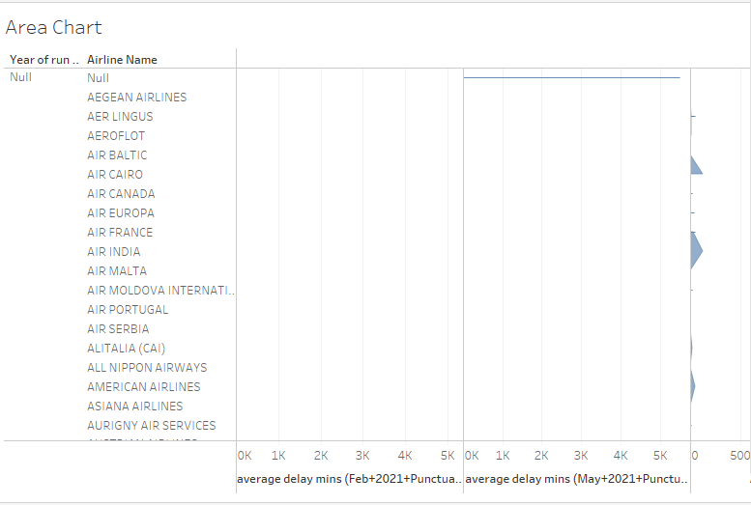

**Figure 1: Area chart**

(Source: self-created in Tableau)

**Aim:** To display the average between the delay of the flights per month.

**Steps:** The average delay per month for all airports may be shown visually using an area chart. This kind of graphic makes it simple to compare the average delay values over many months and offers a clear picture of patterns and trends. For this visualization, data of airline names, name of the airport and number of flights delayed on that particular month has been taken. Through the area chart, delayed flight information can be generated like name of the airport and airline.

**Key findings:** An area chart is advantageous for this use because it makes the fluctuation in average delay over time easily visible. Viewers may immediately identify months with greater or lower average delays and spot any repeating trends by examining the height and form of the coloured regions.

**Visualisation 2:**

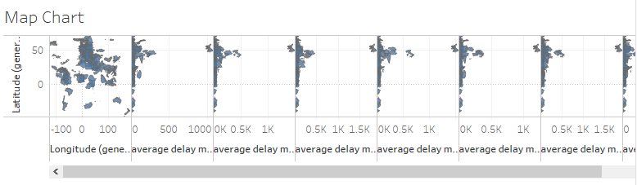

**Figure 2: Map chart**

(Source: self-created in Tableau)

**Aim:** To display the average between the delays of flights for each country.

**Steps:** A map chart is an effective visualisation tool used by the airline industry to depict the typical delays for each destination country. Viewers may readily identify locations or nations with higher or lower average delays because of the geographical representation of the data that is made possible by this. For this visualization, data of airline names, destination and number of flights delayed on that particular month has been taken. Through the map chart, information regarding the delayed flight like name and destination can be generated.

**Key findings:** There are various benefits to using a map chart to show the typical delays for each destination country (Schultz, M. *et al,* 2019). It offers a visual summary of delay patterns throughout various regions, aids in locating areas with larger delays, and draws attention to any differences across nations. Airlines, travel planners, and passengers may all benefit from this information to help them make well-informed choices on flight paths, layovers, and travel arrangements.

**Visualisation 3:**

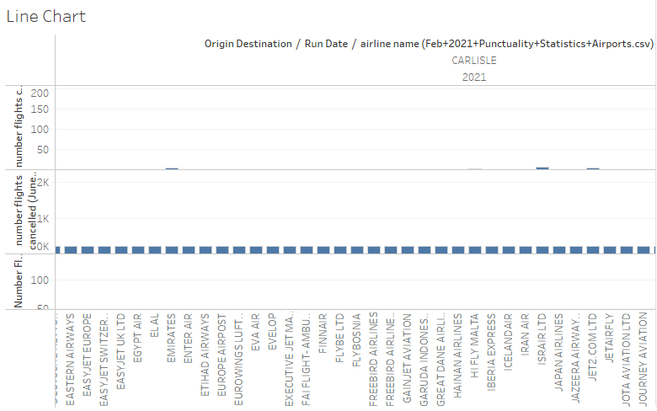

**Figure 3: Line chart**

(Source: self-created in Tableau)

**Aim:** To display the top most 5 airlines in the top 5 locations.

**Steps:** The total amount of flights delayed for the top 5 airlines in the top 5 destinations may be successfully represented by a line chart (Mullan, M., 2019). With the support of this presentation, viewers can observe how flight cancellations have fluctuated over time and find which airlines and destinations have seen the most disruptions. For this visualization, data of airline names, destination and number of flights cancelled on that particular month has been taken. Through the line chart, information regarding cancelled flight can be generated like name of the airline and airport.

**Key findings:** There are multiple benefits to using a line chart for displaying the top 5 airlines in the top 5 locations with the highest number of flight cancellations. It lets users contrast cancellation records across various airlines and spots, notice any quarterly or recurrent trends, and find exceptions or substantial shifts in denial rates.

# Conclusion

In conclusion, efficient database administration is essential for enhancing flight on-time performance in the airline sector. Airlines may aggregate and analyse data from numerous sources by putting in place a data warehouse, which enables them to get insightful information and make data-driven choices. Data consolidation, improved performance, historical data analysis, decision assistance, data integration, and quality are a few advantages of employing a data warehouse. A data warehouse and a business intelligence tool like Tableau together offer additional benefits. It helps businesses to easily connect and visualise data, improve data visualisation and reporting, empower self-service analytics, take advantage of scalability and performance, guarantee data consistency, enable sophisticated analytics and data exploration, and support group decision-making. It's crucial to recognise that building a data warehouse and successfully utilising it might be difficult. These difficulties include managing the ETL process, guaranteeing data security and privacy, managing change, creating data governance and ownership, resolving scalability and performance issues, and assigning sufficient resources. Despite these obstacles, the use of a data warehouse in conjunction with business intelligence tools offers the airline industry significant potential to enhance customer segmentation and loyalty analysis, improve operational efficiency, support network planning and route optimisation, and optimise revenue management. Overall, efficient database management, in conjunction with data warehousing and business intelligence tools, gives airlines the tools and insights required to optimise their operations, boost customer satisfaction, and improve flight punctuality, ultimately resulting in a more successful and efficient airline industry.

# Reference list

**Journals**

Kaewunruen, S., Sresakoolchai, J. and Xiang, Y., 2021. Identification of weather influences on flight punctuality using machine learning approach. *Climate*, *9*(8), p.127.

Zeng, W., Ren, Y., Wei, W. and Yang, Z., 2021. A data-driven flight schedule optimization model considering the uncertainty of operational displacement. *Computers & Operations Research*, *133*, p.105328.

Miao, X., 2022, February. Punctuality Analysis of Aviation Industry Based on Python Data Mining Algorithm. In *2022 IEEE International Conference on Electrical Engineering, Big Data and Algorithms (EEBDA)* (pp. 976-978). IEEE.

de Almeida, E.E. and Oliveira, A.V., 2023. An econometric analysis for the determinants of flight speed in the air transport of passengers. *Scientific Reports*, *13*(1), p.4573.

Liu, J., Zhao, J., Lu, Y. and Wu, Y., 2022, December. Flight Delay Prediction Method Based on LSTM. In *2022 International Conference on Automation, Robotics and Computer Engineering (ICARCE)* (pp. 1-4). IEEE.

Polishchuk, T., Lemetti, A. and Sáez García, R., 2019. Evaluation of flight efficiency for stockholm arlanda airport using opensky network data. In *Proceedings of the OpenSky Workshop 2019: EPiC series in computing, vol. 67* (pp. 13-24).

Peng, W., Lu, M., Zhang, X. and Teng, Y., 2021. Analysis of flight punctuality rate based on complex network. *Journal of Quantum Computing*, *3*(1), p.13.

Nosedal-Sánchez, J., Piera-Eroles, M.A. and Lebbink, D., 2020. Identification and empirical characterisation of flight arrival variation and the impact on departure punctuality. *International Journal of Services and Operations Management*, *35*(3), pp.307-320.

Bubalo, B. and Gaggero, A.A., 2021. Flight delays in European airline networks. *Research in Transportation Business & Management*, *41*, p.100631.

Lemetti, A., Polishchuk, T., Sáez, R. and Prats, X., 2019, October. Analysis of weather impact on flight efficiency for Stockholm Arlanda Airport arrivals. In *ENRI International Workshop on ATM/CNS* (pp. 77-92). Singapore: Springer Singapore.

Hu, P., Zhang, J. and Li, N., 2021, October. Research on Flight Delay Prediction Based on Random Forest. In *2021 IEEE 3rd International Conference on Civil Aviation Safety and Information Technology (ICCASIT)* (pp. 506-509). IEEE.

Conde, J., Munoz-Arcentales, A., Romero, M., Rojo, J., Salvachúa, J., Huecas, G. and Alonso, Á., 2022. Applying digital twins for the management of information in turnaround event operations in commercial airports. *Advanced Engineering Informatics*, *54*, p.101723.

Lin, P.C., 2023. The propagation of European airports’ on-time performance and on-time flights via air connectivity prior to the Covid-19 pandemic. *Journal of Air Transport Management*, *109*, p.102382.

Gu, Y. and Yang, J., 2019, March. Research on Cause and Governance Path of Passenger Disturbance in Flight Delay in Terminal. In *International Academic Conference on Frontiers in Social Sciences and Management Innovation (IAFSM 2018)* (pp. 112-117). Atlantis Press.

Li, J., Zhong, Q., Yi, L., Wang, Q., Zuo, J. and Liu, Y., 2022. Hybrid optimization of arrival and departure flight schedules. In *Proceedings of the 5th China Aeronautical Science and Technology Conference* (pp. 103-119). Springer Singapore.

Rodríguez-Sanz, Á., Valdes, R.M.M.A., Pérez-Castán, J.A., Cózar, P.L. and Comendador, V.F.G., 2021. Tactical runway scheduling for demand and delay management. *Aircraft Engineering and Aerospace Technology*, *94*(1), pp.2-13.

Reitmann, S., Alam, S. and Schultz, M., 2019, June. Advanced quantification of weather impact on air traffic management. In *ATM Seminar* (Vol. 44, pp. 554-567).

Mullan, M., 2019. The data-driven airport: How daa created data and analytics capabilities to drive business growth, improve the passenger experience and deliver operational efficiency. *Journal of Airport Management*, *13*(4), pp.361-379.

Alomar, I., Belitskaya, M. and Belitskaya, A., 2021, October. Comparative Statistical Analysis of Airport Flight Delays for the Period 2019–2020. Almaty International Airport Case Study. In *International Conference on Reliability and Statistics in Transportation and Communication* (pp. 110-124). Cham: Springer International Publishing.

Huang, F., Zhou, D., Hu, J.L. and Wang, Q., 2020. Integrated airline productivity performance evaluation with CO2 emissions and flight delays. *Journal of Air Transport Management*, *84*, p.101770.

Lemetti, A., Polishchuk, T., Sáez, R. and Prats, X., 2019, September. Evaluation of flight efficiency for Stockholm Arlanda airport arrivals. In *2019 IEEE/AIAA 38th Digital Avionics Systems Conference (DASC)* (pp. 1-8). IEEE.